How to: Check UIElement Properties with Coded UI Test

* 1. The following How-to topic will walk you through the creation of an automated test that checks for **UIElement** properties in a web application by using Visual Studio 2010 Coded UI Test. The Coded UI test performs actions on the user interface (UI) controls and verifies that the **UIElement** properties are displayed with the correct values. For this topic, the Mileage Stats Reference Implementation (Mileage Stats) will be the targeted application used for testing.
  2. The automated test we will create in this topic will navigate to the Mileage Stats home page and verify that each of the images contain an **Alt** property with the expected values. This is important to ensure that the site is accessible and usable to all visitors.

# Prerequisites

* 1. This topic requires you to have the same prerequisites required by Mileage Stats:
  + Microsoft Visual Studio 2010 Professional, Premium, or Ultimate edition
  + [Microsoft Visual Studio 2010 SP1](http://www.microsoft.com/downloads/en/details.aspx?FamilyID=75568aa6-8107-475d-948a-ef22627e57a5&displaylang=en)
  + Microsoft .NET Framework 4.0 (installed with Visual Studio 2010)
  + [ASP.NET MVC 3](http://www.asp.net/mvc/mvc3)
  + [Microsoft SQL Server Compact 4.0](http://www.microsoft.com/downloads/en/details.aspx?FamilyID=033cfb76-5382-44fb-bc7e-b3c8174832e2)
  + [ADO.NET Entity Framework 4.1](http://www.microsoft.com/downloads/en/details.aspx?FamilyID=b41c728e-9b4f-4331-a1a8-537d16c6acdf&displaylang=en)
  + [NuGet](http://nuget.org/)
  + [Internet Explorer 9](http://windows.microsoft.com/en-US/windows/downloads/internet-explorer)
  1. It is assumed that the Mileage Stats debug model web application has been deployed to a server running Microsoft Internet Information Services (IIS), and that the test site is <http://localhost/mileagestats>.

# Steps

* 1. In Visual Studio, create a new Test Project named **CheckUIElementProperty**. To do this, point to **New** on the File menu, and then click **Project**. In the New Project dialog, select **Test Documents** under **Test Projects**. Set the project's name to **CheckUIElementProperty**, specify a valid location, and then click **OK**.
  2. Add a Coded UI Test. To do this, in Solution Explorer, right-click the **CheckUIElementProperty** project, point to **Add**, and select **New Test**. In the **Add New Test** dialog, select the **Coded UI Test**. Name the Coded UI Test **VerifyImageAltProperty** and click **OK**. In the **Generate Code for Coded UI Test** dialog select **Record actions, edit UI map or add assertions**, and click **OK**, as shown in the screenshot below.

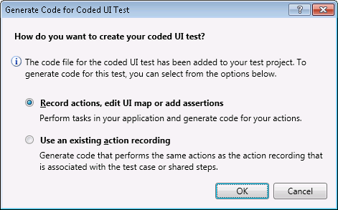

* 1. Record the UI Test as follows:
     1. Click the **Record** button to start recording.



* + 1. Open Internet Explorer.
    2. Navigate to the Mileage Stats home page.
    3. Click the **Record** button to stop recording. Click the **Show Recorded Steps** button to check if the steps were recorded correctly. The coded UI test builder – Recorded Actions dialog should look like the following screenshot.
       1. 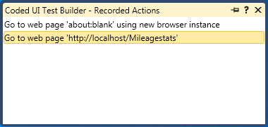
    4. If there are unexpected steps, you can remove them by right-clicking the step you want to delete and selecting **Delete**.
    5. Click the **Generate Code** button. Name the method **GoToHomePage**. Click the **Add and Generate** button. The code will be generated in a file called **UIMap.Designer.cs**. This code can be customized according to your needs.
       1. **Note:** Each time you generate the code from a recorded method, the code in the UIMap.Designer.cs file will be overwritten.
  1. Use the **Coded UI Test Builder** to create a validation method to validate properties of the target UI control. For this example, you will verify that the property of each image on the home page is set to expected values by following these steps:
     1. Add an assertion to the UI control. To do this, drag the crosshairs onto the UI control in your application that you want to test. When the box outlines your control, release the mouse. For example, drag the crosshairs to the mileage status icon, as shown below, on the home page.
        1. **Note:** It will be easier to select the UI elements if the browser is maximized to 100%.
           1. 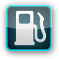
     2. The properties for this control are now listed in the **Coded UI Test Builder - Add Assertions** dialog box.
     3. Right-click the **Alt** property, and select the **Add Assertion**. Leave all values set to the defaults and click **OK**.
        1. 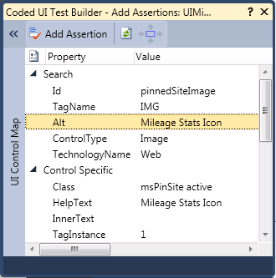
     4. Repeat the above three steps for all images on the home page, such as MyOpenId, Yahoo, and the HTML5 icons. For this test, collect all multi-assertions into one **Assert** method.
     5. Click the **Generate Code** button. Name the method **AssertImageAltProperty**. The following code snippet will be auto-generated in the **VerifyImageAltProperty.cs** file.
  2. C#
     + 1. [TestMethod]
       2. public void CodedUITestMethod1()
       3. {
       4. // To generate code for this test, select "Generate Code for   
           // Coded UI Test" from the shortcut menu and select one of the menu items.
       5. // For more information on generated code, see   
           // http://go.microsoft.com/fwlink/?LinkId=179463
       6. this.UIMap.VerifyAltPropertyMethod();
       7. this.UIMap.AssertImageAltProperty();
       8. }
     1. Verify the assertion method generated in **UIMap.Designer.cs**.
  3. C#
     1. // <summary>
     2. // AssertImageAltProperty - Use 'AssertImageAltPropertyExpectedValues'  
         // to pass parameters into this method.
     3. // </summary>
     4. public void AssertImageAltProperty()
     5. {
     6. #region Variable Declarations
     7. HtmlImage uIMileageStatsIconImage = this.UIBlankPageWindowsInteWindow.UIMileageStatsKnowwherDocument.UIMileageStatsIconImage;
     8. HtmlImage uIMyOpenIDImage = this.UIBlankPageWindowsInteWindow.UIMileageStatsKnowwherDocument.UILoginPane.UIMyOpenIDImage;
     9. HtmlImage uIYahooImage = this.UIBlankPageWindowsInteWindow.UIMileageStatsKnowwherDocument.UILoginPane.UIYahooImage;
     10. HtmlImage uISignInorRegisterImage = this.UIBlankPageWindowsInteWindow.UIMileageStatsKnowwherDocument.UILoginPane.UISignInorRegisterImage;
     11. #endregion
     12. // Verify that 'Mileage Stats Icon' image's 'Alt' property  
         // equals 'Mileage Stats Icon'
     13. **Assert.AreEqual(this.AssertImageAltPropertyExpectedValues.UIMileageStatsIconImageAlt, uIMileageStatsIconImage.Alt);**
     14. // Verify that 'My OpenID' image's 'Alt' property equals 'My OpenID'
     15. **Assert.AreEqual(this.AssertImageAltPropertyExpectedValues.UIMyOpenIDImageAlt, uIMyOpenIDImage.Alt);**
     16. // Verify that 'Yahoo' image's 'Alt' property equals 'Yahoo'
     17. **Assert.AreEqual(this.AssertImageAltPropertyExpectedValues.UIYahooImageAlt, uIYahooImage.Alt);**
     18. // Verify that 'Sign In or Register' image's 'Alt' property equals 'Sign In or Register'
     19. **Assert.AreEqual(this.AssertImageAltPropertyExpectedValues.UISignInorRegisterImageAlt, uISignInorRegisterImage.Alt);**
     20. }
  4. Modify the generated code as follows:
     1. Copy the code in UIMap.Designer.cs and paste it into UIMap.cs.
     2. In UIMap.cs, if not already present, add the following **using** statement:
        + 1. C#
          2. using Microsoft.VisualStudio.TestTools.UITesting.HtmlControls;
     3. If you want to close the browser window automatically after each test case runs, add a **CloseBrowserWindow** function in the UIMap.cs partial class, as follows:
        1. C#
        2. public partial class UIMap
        3. {
        4. ...
        5. ...
        6. public void CloseBrowserWindow()
        7. {
        8. #region Variable Declarations
        9. BrowserWindow currentBrowserWindow = this.mUIBlankPageWindowsInteWindow;
        10. #endregion
        11. currentBrowserWindow.Close();
        12. }
        14. ...
        16. }
     4. Add the following code snippet to the **VerifyImageAltProperty** Class in the **VerifyImageAltProperty.cs** file. The **TestCleanup** attribute in this method marks this method to be executed every time a test method completes its run.
        1. C#
        2. //Use TestCleanup to run code after each test has run
        3. [TestCleanup()]
        4. public void MyTestCleanup()
        5. {
        6. // To generate code for this test, select "Generate Code for   
            // Coded UI Test" from the shortcut menu and select one of   
            // the menu items.
        7. // For more information on generated code, see   
            // http://go.microsoft.com/fwlink/?LinkId=179463
        8. this.UIMap.CloseBrowserWindow();
        9. }
  5. To run the test, Close all browser windows. Right-click inside the **VerifyImageAltProperty.cs** file and click **Run Tests**. The CodedUI Test begins to execute; this will open a browser and will run the application programmatically based on the recorded steps and will assert if the conditions are met. If they are met, the test will pass. Otherwise, they will fail. Once the test completes, the results will be shown in the Test Results window.

# Outcome

* 1. Here we created the Automation test project, which can be used to automate testing of your web application's UIElement **Alt** property.

# Further Reading

* + [Testing the User Interface with Automated UI Tests](http://msdn.microsoft.com/en-us/library/dd286726.aspx) on MSDN
  + [How to: Create a Coded UI Test](http://msdn.microsoft.com/en-us/library/dd286681.aspx) on MSDN